May 2020

Bury Schools Sports Partnership: In School Coaching Programme
Risk Assessment &
PE COVID-19 Policy
November 2020

This has been created in conjunction with the guidance from the Association of
Physical Education, the Youth Sports Trust, Sport England and government guidance on the phased return of sport.

Key principles for supporting safe physical activity:
1. Clean frequently touched surfaces
- Wash hands frequently as part of a clear hygiene regime
- Minimise contact
- Ensure good respiratory hygiene
- Avoid sharing equipment
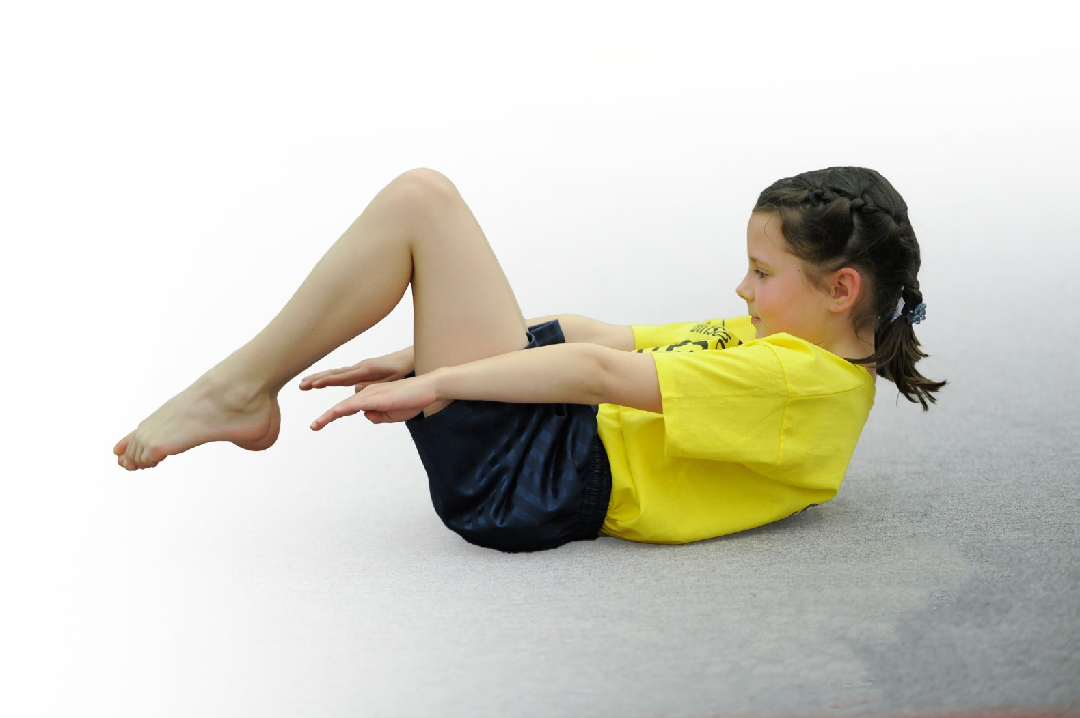

Bury SSP: In School Coaching Programme PE COVID-19 Policy
September 2020
Having read through the guidance provided by AfPE, YST, Sport England and the government, it is clear that PE in schools in England is going to look different whilst COVID-19 is still present. This policy will remain in place until government guidance changes. Everyone at Bury SSP will be required to follow this PE COVID-19 Policy.
Government guidance states that schools have the flexibility to decide how Physical Education and sport will be delivered during the current control measures. Having looked at various NGB websites, this is a very fluid process and thankfully all sports are moving towards returning to the full version of the activity. That said, Bury SSP management and staff understand and recognise the importance of safe and consistent practice across schools, where possible.
The table below shows a summary of the current position for some of our main sports:
Sport | Current Guidance
Football | Until end of July – competitive training could take place with groups of no more than 30  From August – competitive matches were allowed  From September – leagues can commence  Guidelines:  Self-assess for symptoms of Covid  Social distancing before, after and during breaks in play  Hand sanitise before and after games/training  Ball handling should be kept to a minimum  Goal celebrations avoided  Equipment should not be shared e.g. goal keeper gloves
Rugby | Now in phase D of roadmap  Rucks - 2v2 rucks in drills allowed, no team play activity  Lineout – unopposed jumping is ok, no opposed jumping or maul set up after lineout  Tackling – waist or below, 1v1, small group activity, use of bags/shields permitted (cleaned after each use), no tackling above the waist, no holding the ball up, no tackles in games  No scrums or mauls (in practices or in games)
Netball | Stage 4a unlocked (modified training)  30 people per court  Leagues and competitions from 26th September  Equipment sharing permitted (limit where possible)  Regular breaks for hand and equipment sanitisation  Outdoor strongly recommended where possible  Max 30 per court  Friendly matches permitted
Hockey | Now at step 4 (return to local match play)  Touch the ball with your stick, not your hands  No hand shakes  Avoid training that involves excessive running drills in close proximity to others
Other activities that could be considered include:
Walking
Outdoor fitness challenges/ OAA
Footgolf / frisbee golf
Dance & Gymnastics (where pupils can be well spaced out)

Key information in summary that applies to every PE Practical lesson
- Students to remain socially distanced when possible, but to stay in bubbles in line with whole school policy.
- Teachers to meet and greet at the start of lessons and to supervise and dismiss pupils at the end of lessons.
- Students to have regular breaks (as required).
- Students to use hand sanitisers/ wash hands before the lesson and after the lesson (schools to provide).
- The equipment must to be wiped down with appropriate cleaning substances before and after the lesson.
- Each coach will supervise pupils cleaning their own equipment.
- Shared contact of equipment should be kept to a minimum, but where possible not shared, or kept within PE lesson pairings/groups where possible.
- Students should arrive and leave in PE kit/ appropriate clothing.
- Outside PE is preferred so most groups will be outside. Schools should provide coaches with a wet weather contingency plan where this is not possible.
- Coaches will endeavour as much as possible to deliver planned curriculum activities. They will also consult schools before delivery about planned activity and any rules/ restrictions that schools may individually have imposed which may prevent that delivery from happening.
- In the event of a coach catching the virus, they will contact one of the Bury SSP management team as soon as conveniently possible. Bury SSP in turn will contact the school.

