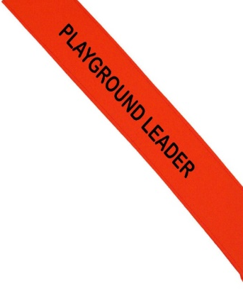
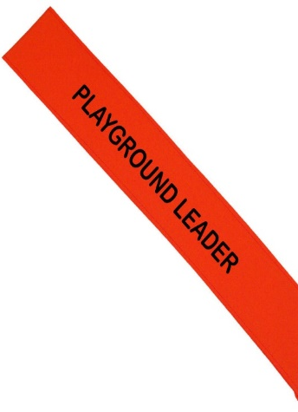
Overall Aim
The aim of Playground Leaders is to introduce and develop leadership skills in Year 5 and 6 children by training them up and getting them to organise activities for other children in the playground.
Who is it for?
Playground Leaders is predominately aimed at Year 5 and 6 children; however, this programme can also be taught to Year 4.
Curriculum or Extra-Curricular
Pupils can use their leadership skills to teach other pupils during morning, lunch or afternoon breaks. Some schools may decide that this can be part of their change 4 life club offer.
How can Playground Leaders help your school?
- It can be an excellent way of engaging your least active pupils.
- The leaders learn to understand the structure of an active session.
- It is a great way of building confidence for both the participants and the leaders.
- Increases participation rates.
- Breaktimes are a lot more structured and safer games are taking place.
- The Leaders gain a sense of responsibility which for some pupils can be an excellent way of channelling behavioural issues.
- With fun active games taking place the playground then becomes a happy place for children to enjoy their breaktimes.

