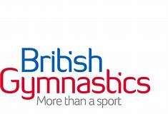
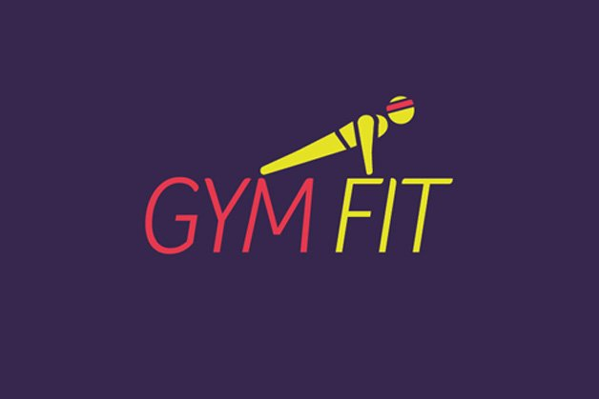

Overall Aim
GymFit is a programme which can be used to improve the general fitness and physical condition while improving gymnastics skills.
Who is it for?
There is beginner, intermediate and advanced work cards which work the upper body, lower body, core and cardio vascular system. The programme is flexible in application and is suitable for a wide range of ability groups. It can be adapted for use by small or large groups, individuals and disabled participants.
Curriculum or Extra Curricular
GymFit can take place in any gymnastics environment whether it be in curriculum time or during an extracurricular activity.
How can GymFit help your school?
- It can enhance and add new ideas to your current gymnastic provision.
- With over 100 exercises to choose from you can add a variety of activities to your sessions.
- It is a flexible, informal, non-traditional training opportunity which offers additional motivation for your participants.
- It will help to improve the fitness levels of your gymnasts
- It help the health and mental wellbeing of pupils
- Its fun, dynamic and challenging to all.

